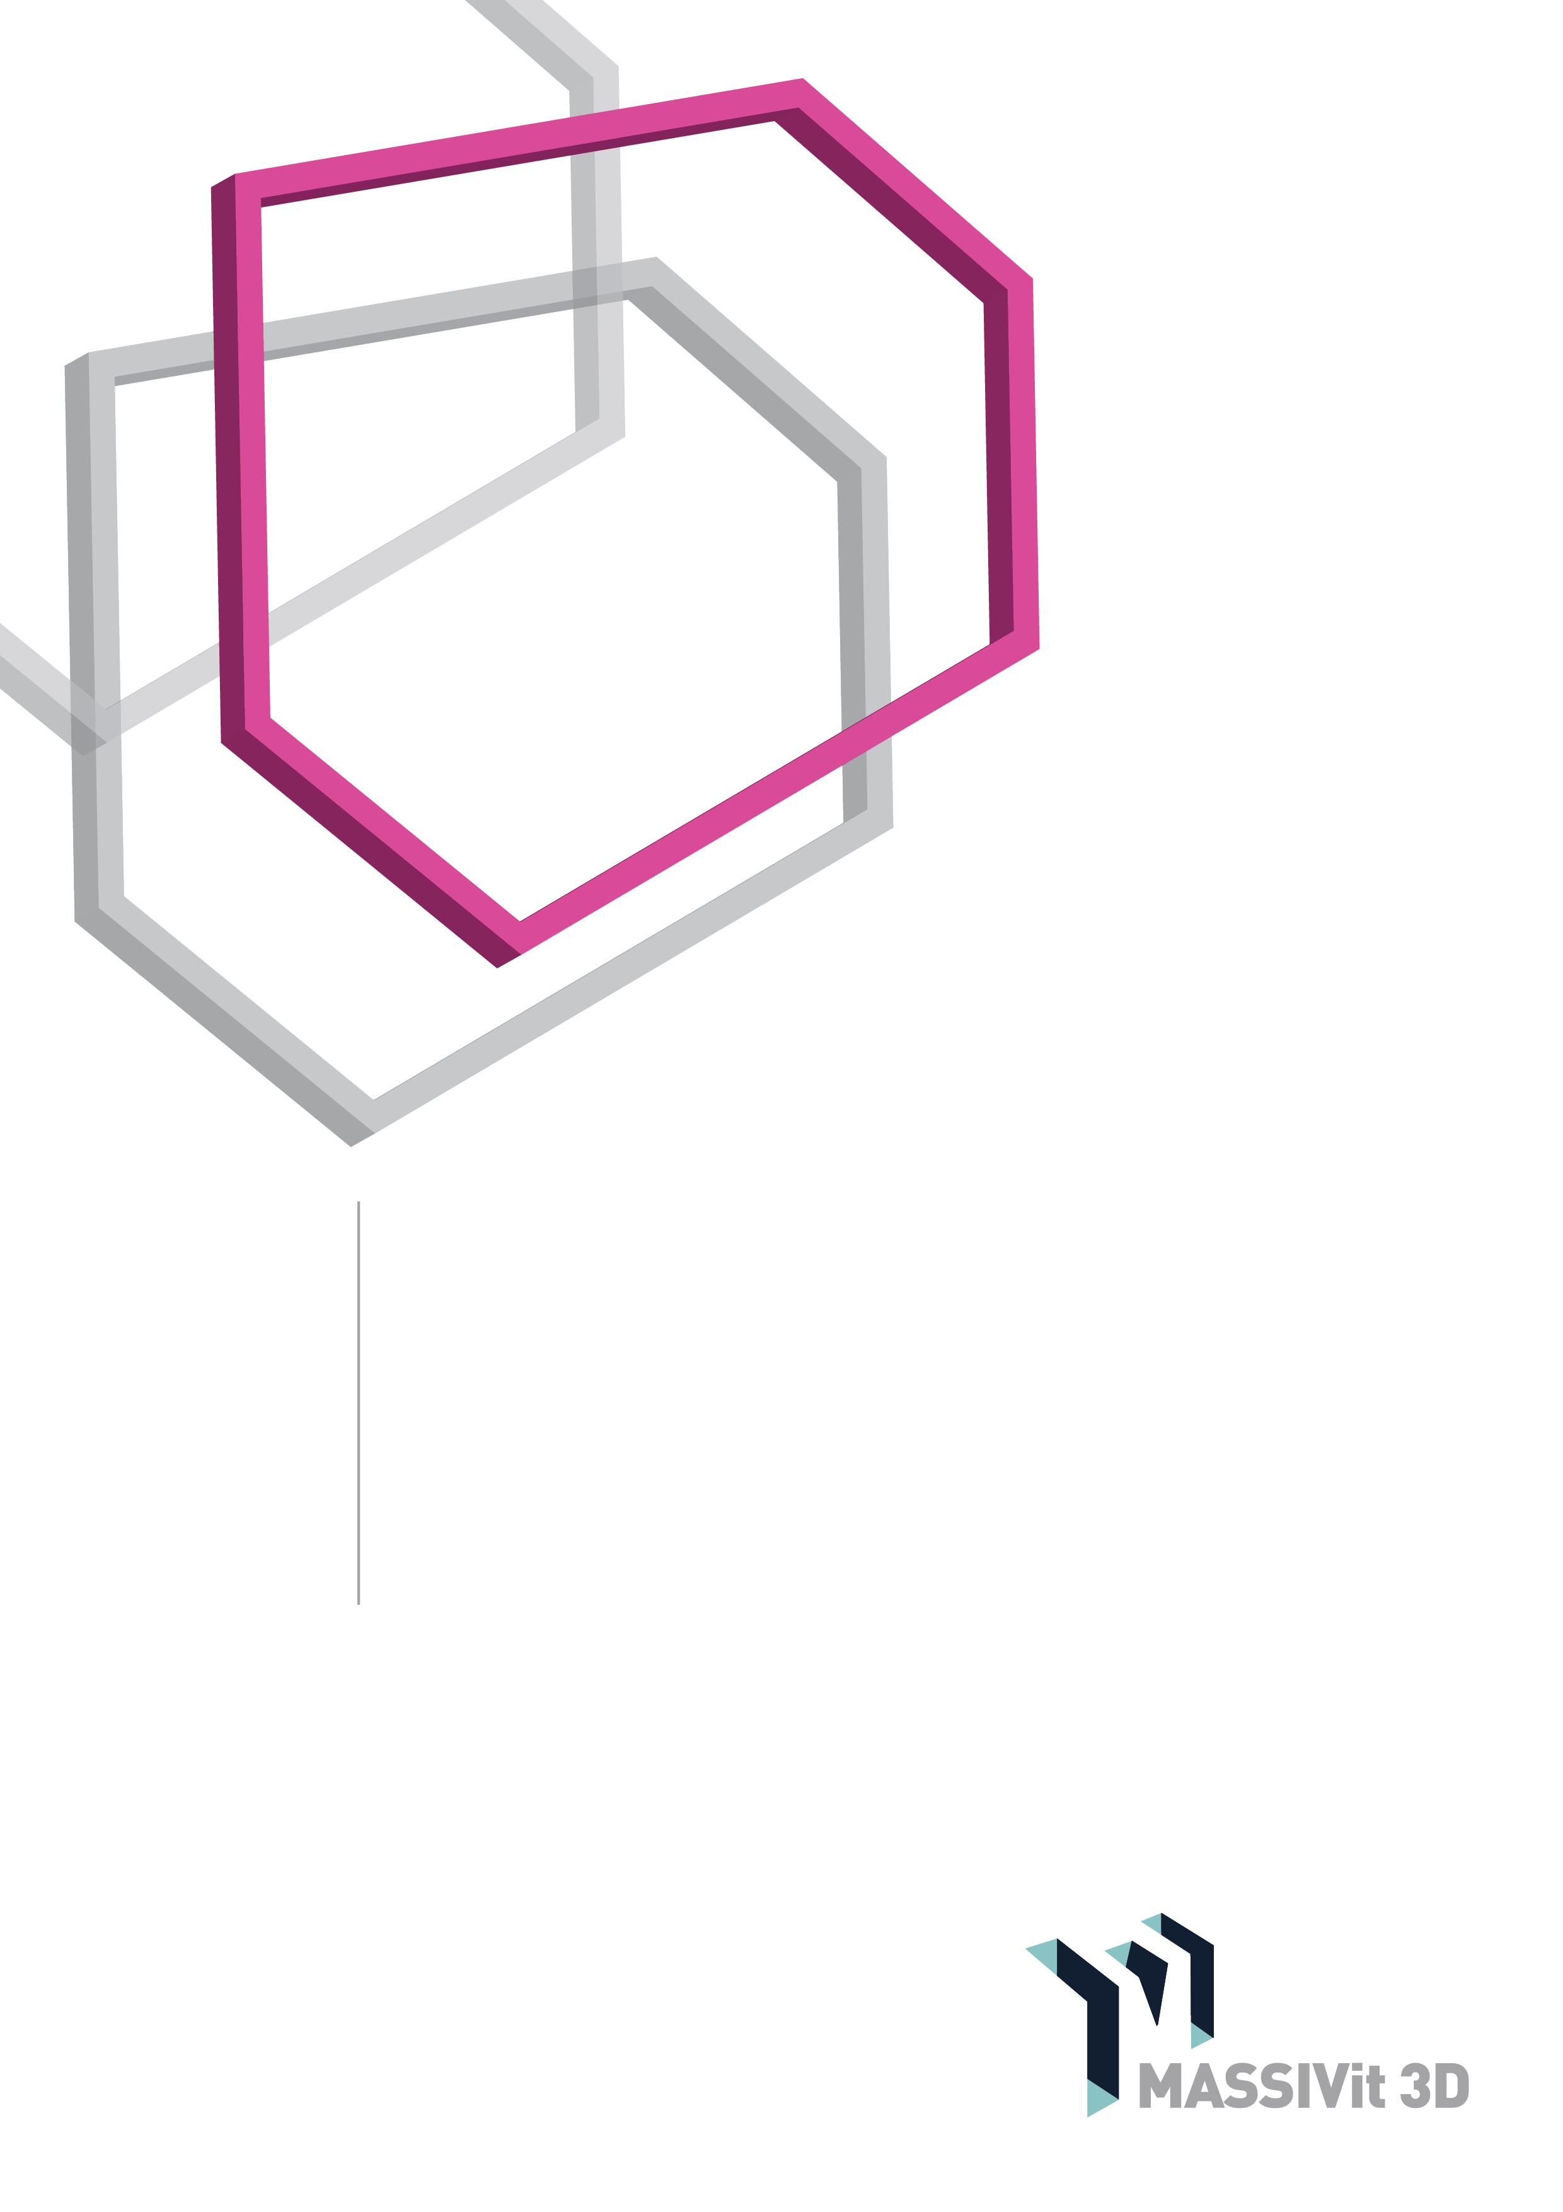lk

Massivit

HOW-TO GUIDE

Hot coatings: Hot Polyurethane and Hot Polyuria

[www.massivit.com](http://www.massivit.com)

The information provided in this document is believed to be accurate and reliable. However, no responsibility is assumed by MASSIVit 3D for the use of this document or for the performance of any materials mentioned. MASSIVit 3D reserves the right to make changes to this document or any material included in it at any time and without notice.

Published on December 2017

© Copyright MASSIVit 3D 2017

**Introduction**

3D printing is characterized by visible print layers, that often needs to be smoothed and hidden. One way to obtain a smooth surface on a printed Massivit model is to coat it with hot coatings.

Hot coatings are a sprayable two-part coating. They can be based on polyurethane, or polyuria, or a mixture of both. Once applied, they will cure within seconds to a hard surface.

When applied properly, theyprovide a good outer surface for Massivit prints. These coatings provide a near-perfect cover, and hide the print layers, eliminating the need for prolonged polishing of the model. In addition, applying a hot coating to a model improves its durability. Depending on the material, it can make the model less brittle, and improve its fire resistance. Some hot coatings, especially flexible hot polyuria, will make the model virtually unbreakable.

This guide will demonstrate how to apply a hot coating using two specific products, but it is also valid for a wide range of similar materials. The specific materials used in this document are:

* EasyFlo Spray FR- by polytek, an type of **Hot rigid polyurethane**
* XS 350 – by line-x, a type of**Hot flexible polyuria**

**When to use**

Although hot coatings can be used on any model, we recommend using it mainly on big objects that need to withstand extreme outdoor conditions, and that are to be seen from far. The reason is that the material application is complicated and requires skill and practice.

Listed below is a table of advantages and disadvantages that can help you to decide if the method is right for a project.

|  |  |
| --- | --- |
| Hot coatings - advantages | Hot coatings - disadvantages |
| Adds strength to the model, to the point that certain coatings will make the model virtually unbreakable | Difficult to apply, and requires special equipment and expertise |
| Enhances the resistance of the model to weather conditions | May have a grainy texture (similar to an orange peel) |
| Enhances the fire-retardant properties of the model | Non-transparent, not suitable for internally lit models |
| Covers the printed layers and eliminates the need for polishing | Might cover over small details |

**Materials Properties**

Each coating material in this family has its own characteristics. Before starting a project, it is advisable to seek advice about which material to use, and to read the data sheet carefully and choose accordingly. The table below is an example of a comparison between two types of materials:

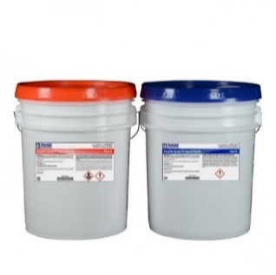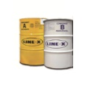

|  |  |  |
| --- | --- | --- |
|  | **XS 350** | **EasyFlo Spray FR** |
| Mix ratio | 1:1 by volume | 1:1 by volume, or 100:90 by weight |
| Color of mixed material | Off-white- pigment can be added | Off-white- pigment can be added |
| Pot life, min | 3 to 6 seconds | 5 seconds |
| Shore Hardness | 60D | 75D |
| USFDA | USFDA Coating Regulations for Incidental-Food-Contact Applications | No |
| Fire retardant | No | UL-94 (V-0) fire-retardant plastic |
| Can be polished | Very hard to polish | Yes |
| Impact resistant | Extreme (up to small firearms) | Some |
| Can be painted | Yes | Yes |
| Spray equipment | High pressure heated reactor only – graco  h-XP2 | Graco E-10 or cartridge gun |

**How to use**

Hot coating materials react extremely quickly. Therefore, a simple spray gun cannot be used to apply them. The two parts of the material should be mixed only when they exit the spray gun, so it is essential to use a special spraying system.

Spraying systems suitable forhot coating, fit into two main categories:

1. Portable spray guns, that use disposable cartridges and disposable tips
2. A reactor system, which heats up the material and circulates it back and forth to a special gun. The gun, in turn, can be air-purged to enable continuous work

Tip

Since the use of the spray systems requires high skill set, we recommend that you give the first few jobs to an external contractor. Only upon getting satisfactory results, invest in capital equipment

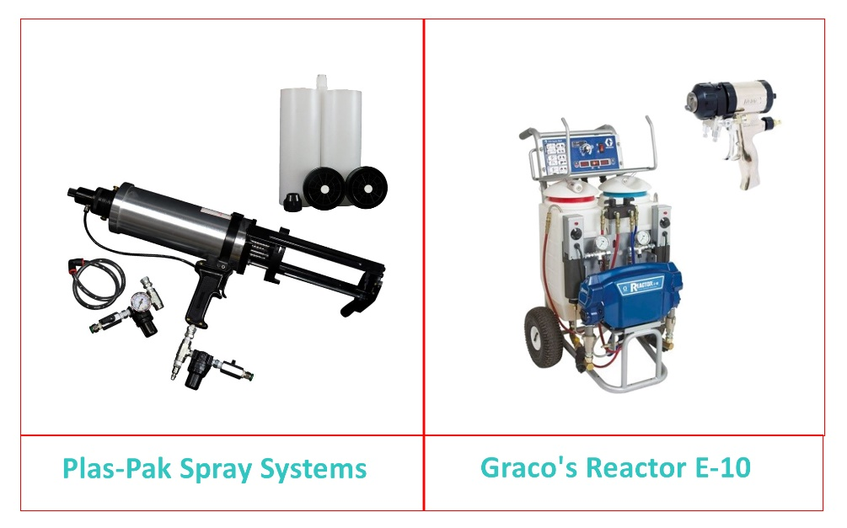

Although portable spray guns are cheaper, we recommend using a reactor system for the following reasons:

* A reactor system is capable of heating the material, thus improving its flow and viscosity. Some hot materials must be heated and cannot be applied from a simple cartridge gun.
* A reactor system has a variety of pressure options that can be set according to the needs of the specific model.
* Spraying using a cartridge gun will always give an inferior and grainy surface, compared to that from a reactor.
* Reactor systems can load large amounts of material in their containers, enabling continuous work without the need for reloading

It is also advisable to use an experienced outside contractor for occasional jobs, since achieving good results requires skill and expensive equipment.

Before starting to spray make sure that the work area is ready for comfortable and safe work; prepare the model, the workspace, and the gear in advance.

**Before starting to work**

**Workspace**

The workspace for coating the models should be large enough to allow a person to walk around the model, reaching it from all sides, with at least one-meter clearance on all sides.

The hot spray material is not a regular paint, but a hard plastic, that may damage any surface or equipment it comes in contact with; the workspace walls and floor should be covered with disposable plastic sheets.

Spraying should be done in an enclosed space, with air extraction, in accordance with all local regulations. Before use, read the MSDS data sheet for the material. Avoid spraying the material near people not wearing full protective gear.

**Protective gear**

The person spraying, and anyone else near it, must at all times wear full protective gear that includes: a full protective suit that covers the head and shoes, gloves, and a full-face respiratory mask which protects the face and eyes. Air filters should meet the manufacturer's requirements, according to the safety data sheet. In any case, don’t work with any material without reading its safety data sheet.

**Preparing the model**

The model surface should be clean of any impurities, dust, and polishing residues. If there are large defects, it is advisable to polish them out before starting.

The surface of the model must be completely clean of any moisture or water. The purity of the surface model is very important as moisture or dirt can easily cause blistering. The polyurethane coating is sensitive to moisture, while polyuria is not.

As a rule of thumb, it is better to coat the model in its entirety rather than in parts since it can add strength the connection points. However, if the model is large, or complex, it may be better to coat it in parts.

Above are blisters caused by water and moisture on the surface of the printed model.

**Spraying emphasis**

Check that the compressor feeding the spraying system is free of water. Use a water trap as an additional precaution.

When starting, spray the first few times on a disposable plastic sheet and not on the model itself, to avoid damaging the printed model, if there is a problem. This step will also help you adjust the pressure to obtain the desired coating.

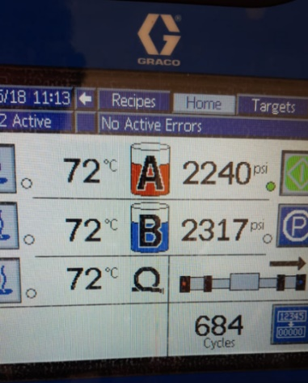Adjust the compressor pressures and heat until you get the desired result. Note that the exact amount of heat and pressure vary according to the spraying system, climatic conditions, and personal preference. It essential to experiment before the starting a spraying session. (see image).

Even though hot coatings harden in seconds, allow 2 to 3 minutes for the coating to cool down and dry up entirely before touching or moving the model.

Here you can see the settings being used in spraying XS-350. Note the temperature and pressure

**Examples of spraying**

In this section we will review some projects, one using Hot Polyurethane, pigmented with grey UV protecting paint, and the other using Hot Polyuria, pigmented with black paint.

The model is fixed in place such that a person can walk around it. Note the walls and floor covered with disposable plastic sheets.

It is important to spray from a variety of angles. Note that all the people are wearing full protective gear.

After the main spraying, we flipped the model to reach especially difficult places. Plan the spraying sequence in advance. Notice the spray on the wall, done to test the material and pressures before spraying the actual model.

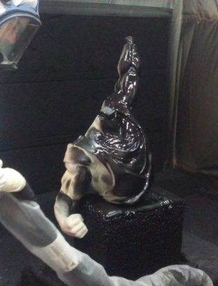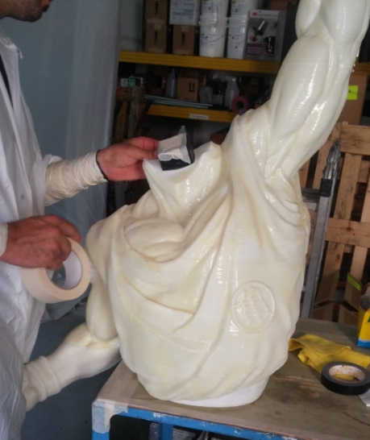

If a single large model is sprayed in parts the seam areas, which should align precisely, should be masked with tape to prevent spray from reaching them.

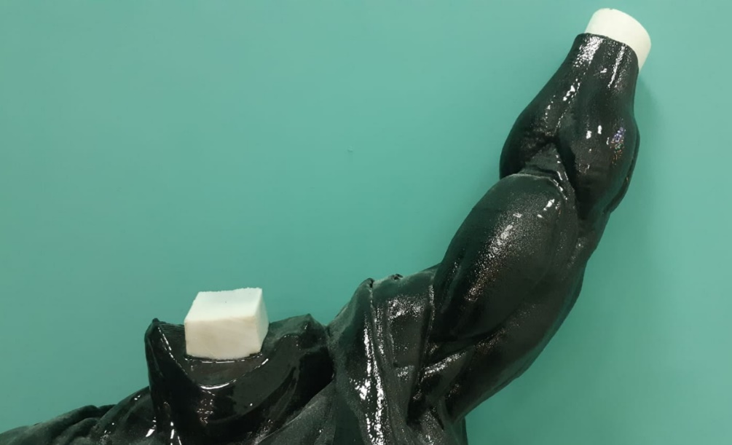

Immediately after spraying, we removed the tape mask. If we had waited, it would not have been possible to cut it from the model

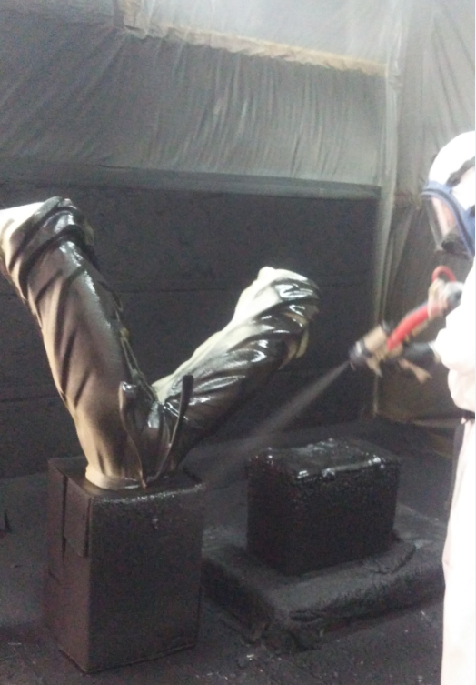

In this example, the model is placed on a platform, and the entire work area is covered with plastic. The operator is completely protected

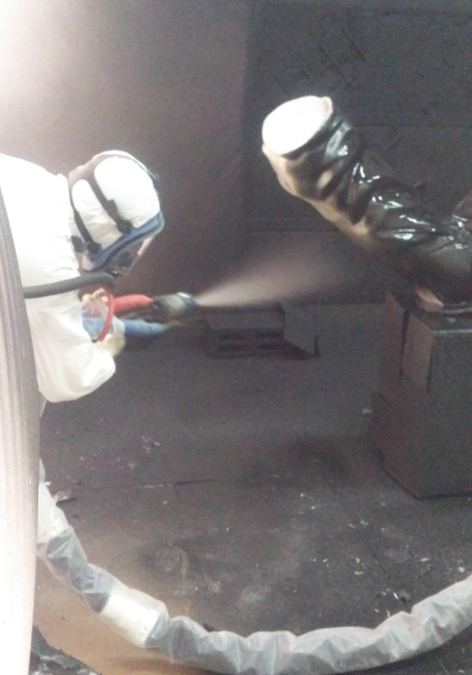

Verify in advance that all sections of the model can be reached.

**Cleanup**

Tools should be scraped clean before the plastic hardens. Denatured alcohol is a good cleaning solvent, but must be handled with extreme caution owing to its flammability and health hazards. Work surfaces can be coated with wax or a release agent so that the cured plastic can be easily removed.

**Finishes & Final touches**

In general, once the object is coated with hot coatingit is already an attractive finished product, and ready for painting.

If needed, it is possible to polish the model for an even smoother look. Take this into account when choosing the coating material: typically, rigid materials can be polished, while flexible materials are much harder to polish.

